

**Technologies of Information**

**and Communication (TIC)**

Name: Frouda Asmaa

Table of Contents

Introduction 4

Definition of ICT: 4

Importance of ICT in Modern Society: 4

Objectives: 4

History and Evolution of ICT 5

1. Early Information Systems (1950s-1960s): 5

2. The Emergence of the Internet (1980s-1990s): 5

3. Web 2.0 and Social Networks (2000s): 5

4. Impact of Mobility and Cloud Computing: 5

Components of ICT 6

2. Software: 6

3. Networks and Services: 6

Benefits of ICT 7

Examples of ICT Applications 7

Challenges and Limitations of ICT 8

Future Evolution of ICT 9

technologies related to TIC 9

1. Google Services 9

− Google Drive 9

− Google Docs 9

− Google Workspace 9

− Google Cloud Platform (GCP) 9

− Google Classroom 9

− Google Analytics 9

2. Microsoft Tools 10

− Microsoft Office Suite 10

− Microsoft Word 10

− Microsoft Excel 10

− Microsoft PowerPoint 10

− Microsoft Teams 10

− OneDrive 10

− Azure 10

− Visual Studio 10

− Power BI 10

3. Git 11

1) What it is 11

2) Features 11

4. GitHub 11

1) What it is 11

2) Features 11

Key Statistics 11

Conclusion 12

References 12

# Introduction

Definition of ICT:  
Information and Communication Technologies (ICT) encompass all technologies that facilitate the access, storage, transmission, and manipulation of information. This broad field includes tools such as computers, the internet, telecommunications, and digital platforms, enabling the flow of information across diverse channels.

Importance of ICT in Modern Society:  
ICT has become the backbone of global connectivity, driving innovation, increasing productivity, and enabling seamless communication. Its integration into businesses, education, healthcare, and governance has led to transformative changes worldwide.

Objectives:  
1. To explore the history and evolution of ICT.  
2. To understand its components and applications.  
3. To analyze its benefits, challenges, and future prospects.

# History and Evolution of ICT

1. Early Information Systems (1950s-1960s):  
The era of early computers marked the beginning of ICT, with mainframes used for basic data processing and calculations. These systems laid the foundation for modern databases and networks.

2. The Emergence of the Internet (1980s-1990s):  
The development of the internet revolutionized ICT by connecting institutions and businesses globally. The creation of the World Wide Web in 1989 enabled widespread access to information.

3. Web 2.0 and Social Networks (2000s):  
The introduction of user-generated content and interactive platforms like Facebook, Twitter, and YouTube transformed how people communicate and share information.

4. Impact of Mobility and Cloud Computing:  
The proliferation of smartphones and cloud-based solutions has made information accessible anytime and anywhere, driving a shift toward flexible work environments and real-time data access.

|  |  |  |
| --- | --- | --- |
| **year** | **ICT Milestone** | **Impact** |
| 1950  1980  1990  2000  2010  2025 | First Mainframe Computers  Internet Emergence  Development of the World Wide Web  Web 2.0  Rise of Cloud Computing  Projected ICT Market | Data processing  Global connectivity  Information accessibility  User-generated content and social media  Flexible, remote access to data  $6,000 billion |

# Components of ICT

1. Hardware:  
- Computers: Desktops, laptops, and servers form the core infrastructure for ICT.  
- Networks: LAN, WAN, and wireless technologies facilitate communication and data sharing.  
- Storage Solutions: Modern data storage includes SSDs, HDDs, and cloud storage services.

2. Software:  
- Operating Systems: Examples include Windows, macOS, and Linux.  
- Applications: Ranging from productivity tools like Microsoft Office to specialized software like ERP systems.  
- Development Tools: Programming languages such as Python, C++, and Java support the creation of innovative applications.

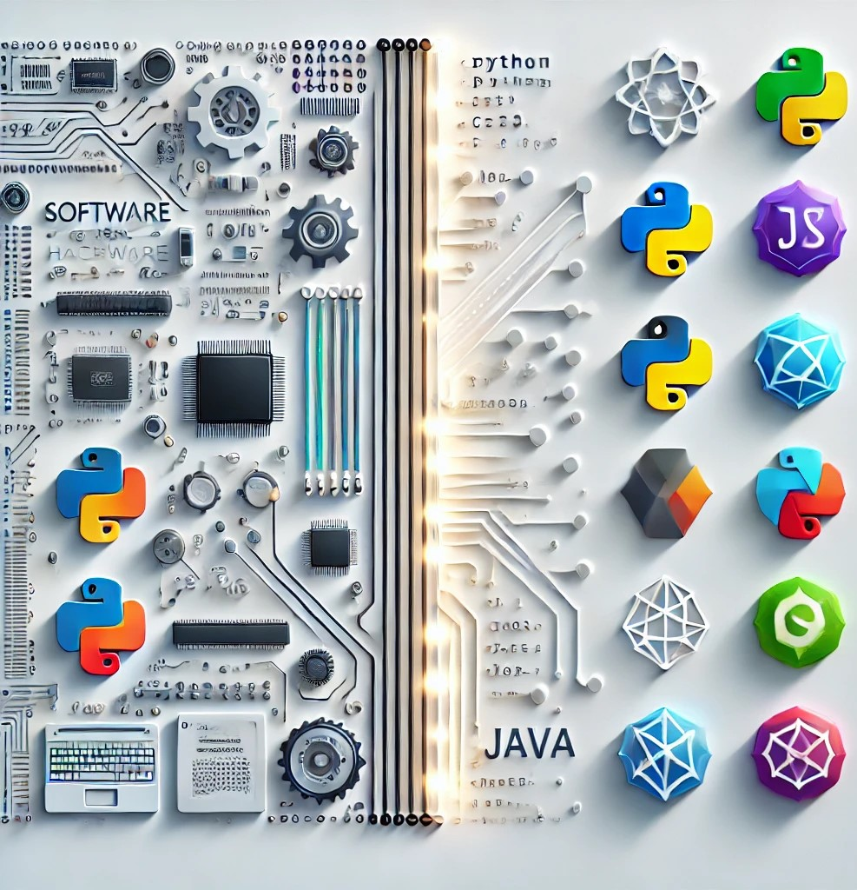3. Networks and Services:  
- Internet Protocols: Fundamental technologies like TCP/IP enable the global internet.  
- Social Media Platforms: Facilitate communication and business networking.  
- Online Services: E-commerce, streaming platforms, and cloud-based tool

# Benefits of ICT

1. Enhanced Communication: Instant connectivity across the globe fosters collaboration and innovation.

2. Access to Information: ICT provides vast repositories of knowledge through search engines and databases.

3. Economic Growth: Digital transformation has created new business opportunities and increased efficiency.

4. Educational Access: Distance learning platforms bring education to remote areas.

5. Healthcare Advancements: ICT supports telemedicine and health information systems.

# Examples of ICT Applications

1. E-Learning: Platforms like Coursera and Khan Academy enable global learning opportunities.

2. Telecommuting: Remote work solutions utilize tools like Zoom and Microsoft Teams.

3. E-Commerce: Platforms such as Amazon and eBay revolutionize retail.

4. Digital Healthcare: Telemedicine apps improve patient care.

5. Smart Cities: IoT-enabled solutions optimize urban management.

# 

# Challenges and Limitations of ICT

1. Digital Divide: Unequal access creates a gap between urban and rural populations.

2. Cybersecurity Threats: Rising risks of hacking and data breaches require robust defenses.

3. Privacy Concerns: Personal data usage demands strict regulation.

4. Infrastructure Costs: Developing nations face challenges in deploying ICT infrastructure.

5. Over-Reliance: System failures can disrupt critical operations.



# Future Evolution of ICT

1. Artificial Intelligence (AI): AI-driven technologies will transform industries through automation and advanced analytics.

2. Internet of Things (IoT): Smart devices will enhance connectivity in homes, cities, and industries.

3. Virtual Reality (VR) and Augmented Reality (AR): Emerging technologies will redefine learning, gaming, and workplace training.

4. 5G Networks: High-speed connectivity will unlock new possibilities for ICT applications.

5. Cloud Computing Expansion: Cloud services will continue to grow, offering scalable and efficient solutions.

# technologies related to TIC

Technologies related to Information and Communication Technology (ICT) include a broad range of tools, platforms, and services that facilitate communication, data management, and collaboration. Here's an overview of the mentioned technologies:

## 1. Google Services

* Google Drive: Cloud storage for file sharing and collaboration.
* 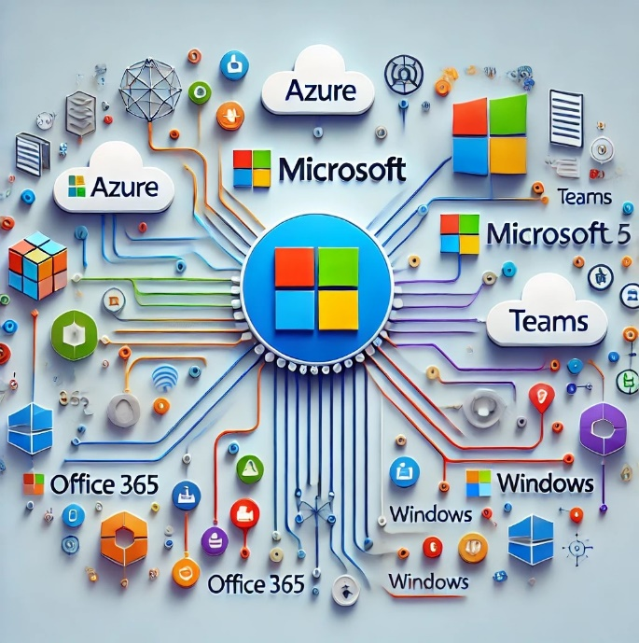Google Docs: Sheets, and Slides: Online tools for word processing, spreadsheets, and presentations, enabling real-time collaboration.
* Google Workspace: A suite of productivity tools including Gmail, Calendar, meet (for video conferencing), and Keep (for note-taking).
* Google Cloud Platform (GCP): A cloud computing service offering infrastructure, analytics, and AI solutions.
* Google Classroom: A platform for educators to manage learning resources and communication with students.
* Google Analytics: A tool for website traffic and performance analysis.

## 2. Microsoft Tools

* Microsoft Office Suite: Includes Word, Excel, PowerPoint, and Outlook for productivity tasks.
* Microsoft Word: A word processing application for creating and editing text documents.
* Microsoft Excel: A spreadsheet program used for data analysis, calculation, and visualization.
* Microsoft PowerPoint: A tool for creating and delivering multimedia presentations
* Microsoft Teams: A collaboration platform with chat, video meetings, and file sharing.
* OneDrive: Cloud storage integrated with Windows and Microsoft Office.
* Azure: A cloud computing service offering virtual machines, AI, data analytics, and more.
* Visual Studio: An integrated development environment (IDE) for software development.
* Power BI: A business analytics tool for interactive data visualization and business intelligence.

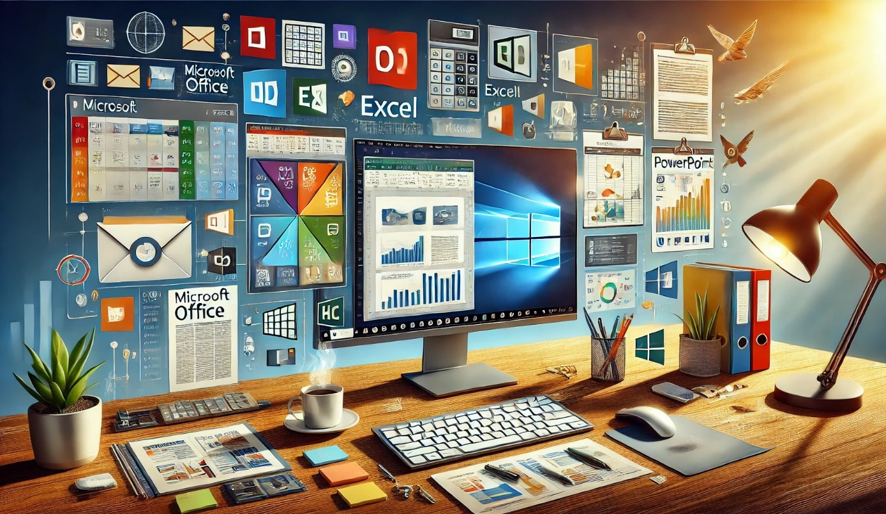

## 3. Git

1. What it is: A distributed version control system used to track changes in source code during software development.
2. Features:

* Enables collaboration among developers.
* Trucks history and facilitates branching and merging of code.
* Works locally, making it fast and offline-friendly.

## 4. GitHub

1. What it is: A web-based platform for version control using Git, as well as a collaborative tool for developers.
2. Features:

* Repository hosting for code.
* Collaboration tools such as pull requests and code reviews.
* GitHub Actions for CI/CD automation.
* Project management tools like Issues and Projects.
* A vibrant community for open-source development.
* These technologies enhance productivity, streamline workflows, and foster collaboration across diverse fields such as education, business, and software development.

# 

# Key Statistics

1. Global Internet Users: Exceeded 5 billion in 2023.

2. Mobile Penetration Rate: Reached 70% globally in 2024.

3. Projected ICT Market: Expected to reach $7 trillion by 2026.

# Conclusion

ICT has revolutionized how the world operates, enabling unprecedented connectivity and innovation. As the field continues to evolve, it will play an even more integral role in shaping industries and societies.

# References

1. International Telecommunication Union (ITU).

2. Organisation for Economic Co-operation and Development (OECD).

3. Gartner Reports.

4. Official Websites of Leading ICT Companies.

5. Research Articles and White Papers on ICT Trends.